Duckie Visual Guide
This is a visual guide to Duckie by Le Gateau Chocolat.

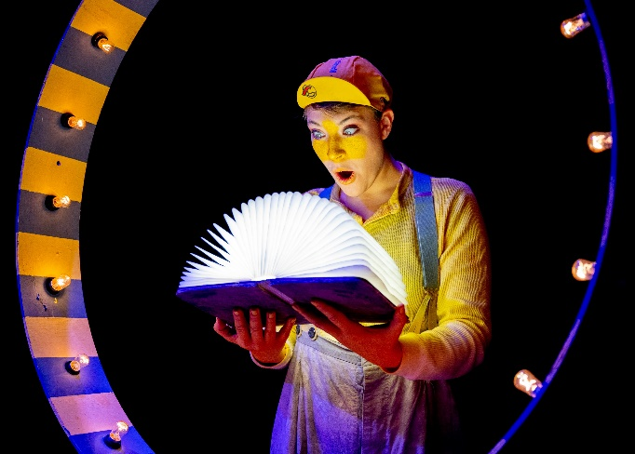 | Duckie is a show for families. It’s based on the story of The Ugly Duckling.  The show is about celebrating difference. Everybody is different and that can be a really great thing.
 | There is lots of music and singing in the show. Sometimes the characters sing about what they are thinking or feeling instead of talking.
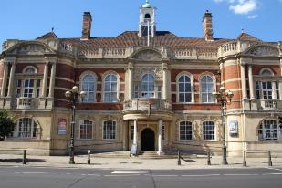 | It takes place at Battersea Arts Centre.
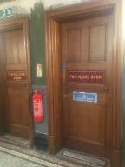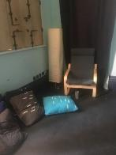 | The performance is a relaxed performance. This means you can move and make noise. You can leave the show and come back in at any point. There is a chill out space on the same floor as the performance.
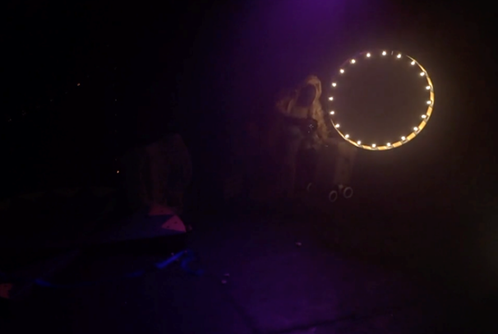 | The start of the show is dark, with a ring of bright lights at the back of the stage.  We have a sensory adaptive performance on Saturday 19 February at 11am. This means this performance won’t be too dark.
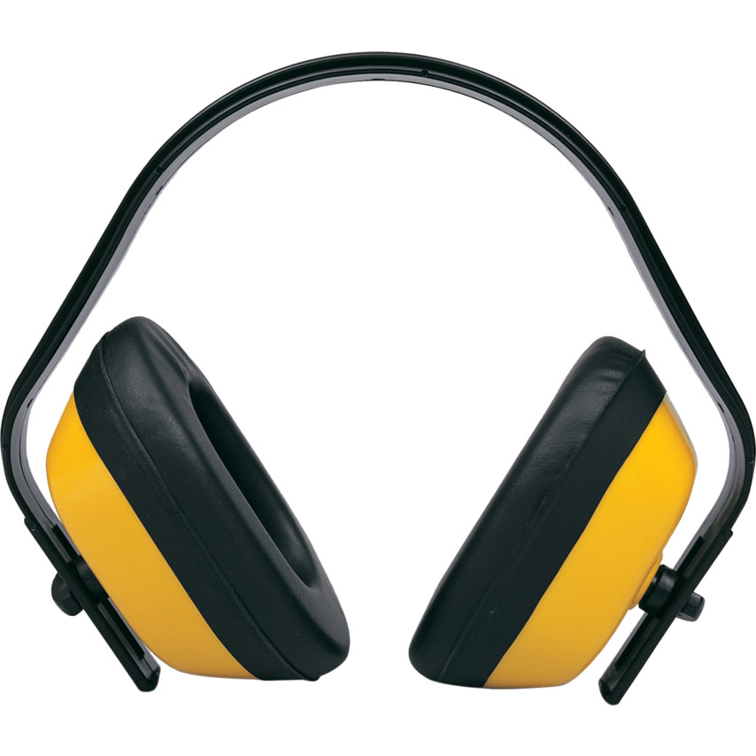 | The show is not very loud but there is one loud part at the end, when the character Duckie is shouted at by lots of other animals.  You can wear ear defenders. Our staff at Battersea Arts Centre can give you a pair.  The sensory adaptive performance on Saturday 19 February at 11am will be quieter.
There is haze in the show.

You can move away from the haze if it makes you feel uncomfortable. If you need to leave the show when the haze appears, that’s ok. You can ask a Battersea Arts Centre staff member to let you know when the haze has gone.

Who are the Performers?
There is one performer. They are called Paula.
Paula will act and pretend to be different people during the show. There is also the voice of the narrator, the person telling the story. There are other voices like Duckie’s Mum, the Lion, the flamingos and the mouse.
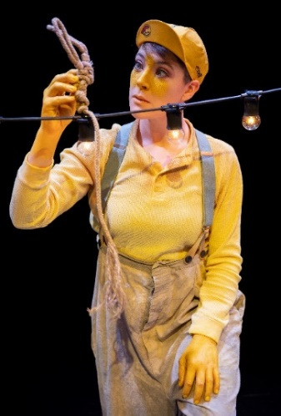 | This is Paula playing the character Duckie.
What happens?
 | - The show starts with a dark stage. There is a ring of bright lights to the right on the stage. There is a platform and some boxes to the left, with a string of lights over the top.
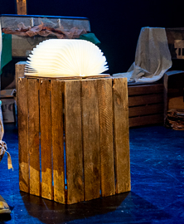 | Paula walks onto the stage, playing the character in a big coat with the woolly hat.  This character finds a book. The book is brightly lit up.  The narrator starts to talk. We never see the narrator.  The narrator tells us that a long time ago, there were lots of animals.
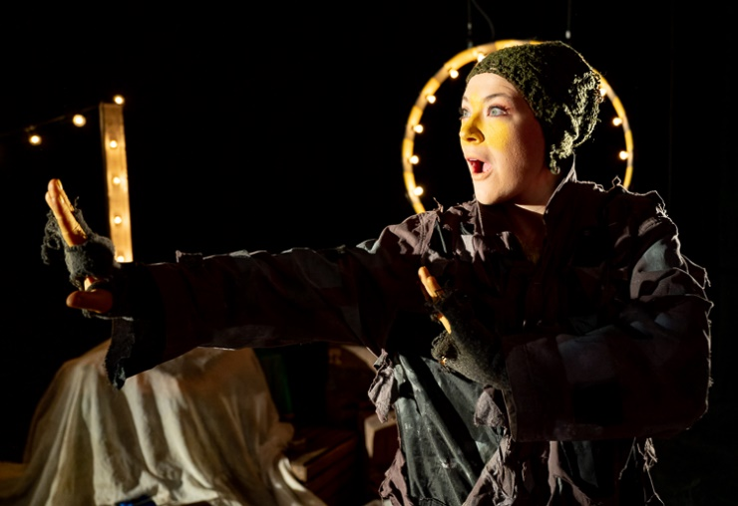 | The character in the woolly hat starts singing. They sing “come with me, and you’ll be in a whole world of your imagination.”  The narrators says that a little yellow duck called Duckie was born to Mrs Duck and Mr Duck.
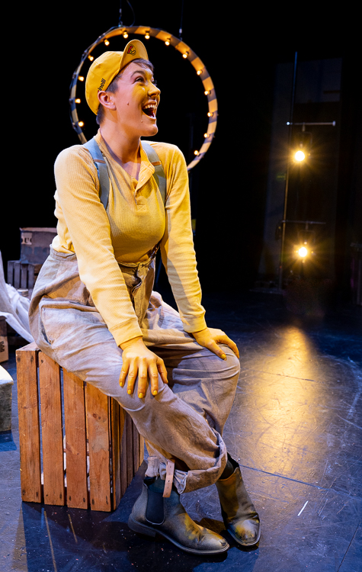 | The character in the woolly hat jumps up and takes off the coat. They take off the woolly hat and puts on a yellow hat.  This means that Paula is now playing Duckie.
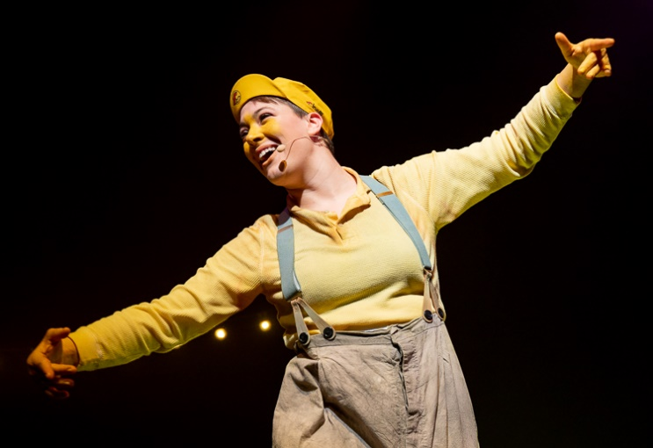 | The voice of Duckie’s mum tells Duckie that ducks don’t sing, ducks should only quack.  Duckie’s mum asks the audience to quack along with her.  You can quack along if you want to but it is ok if you do not want to.  Duckie burps instead of quacks.  Then Duckie’s mum tries to teach Duckie to dance.  We hear children’s voices moaning that Duckie is getting it wrong.
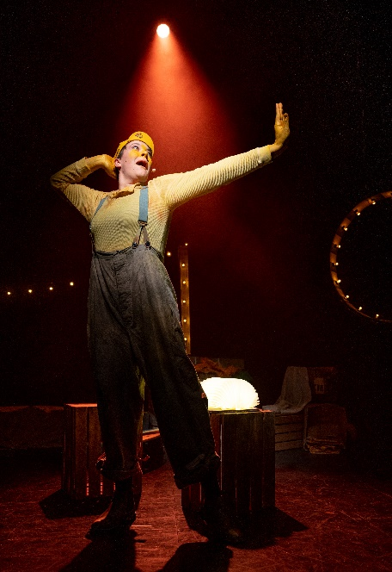 | Duckie’s mum sounds even more annoyed and we hear the voices telling Duckie he is ugly.
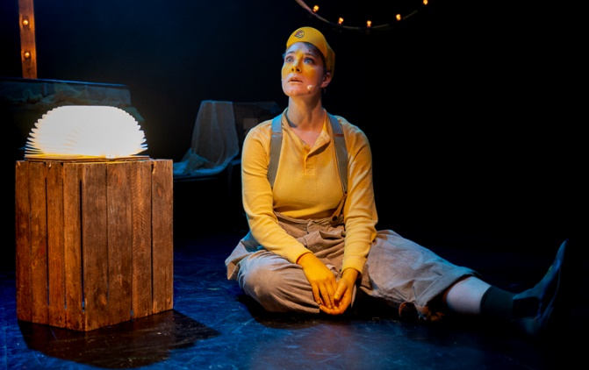 | Duckie looks sad and sings a sad song.  The narrator says that Duckie decides to find new friends in the circus.
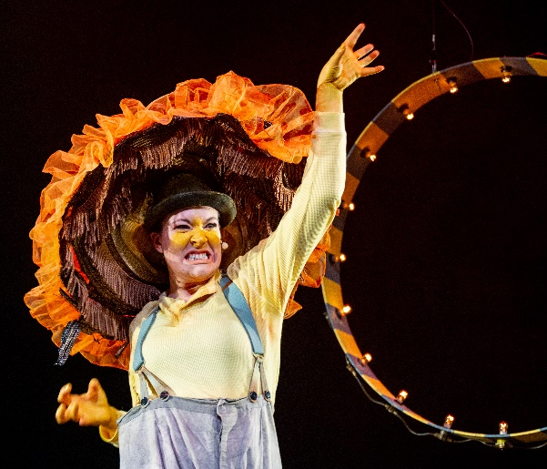 | The narrator tells us that Duckie finds a lion. We hear the lion roar.  Duckie puts on a head-dress which looks like a lion’s mane.
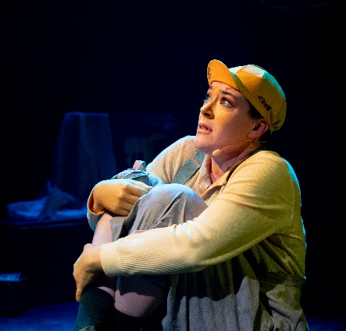 | Suddenly, we hear a lion’s deep voice. It tells Duckie that he is too small and weak to be a lion. Duckie is scared.
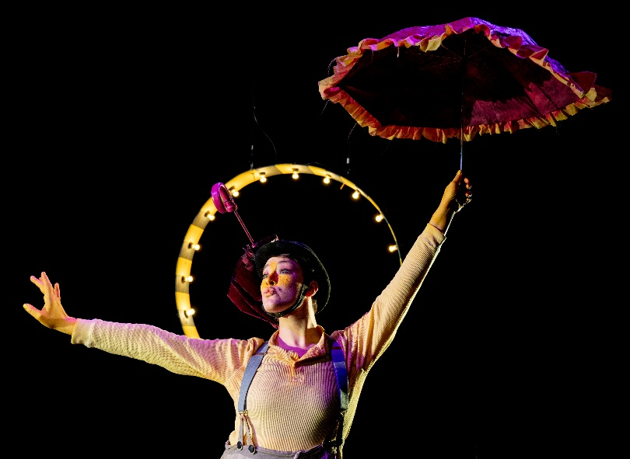 | Duckie runs away from the lion and finds a flamingo.  Duckie puts on a hat with a pink umbrella on it, so he can look like a flamingo.  Duckie practises being a flamingo.  We hear the flamingo’s shouting at Duckie to stop. The flamingos shout that Duckie is not pink like them and he cannot be like them.
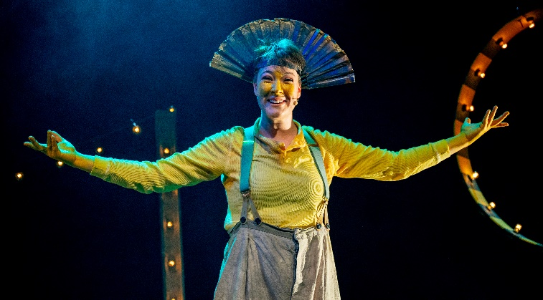 | Duckie puts on a peacock hat.  Fast drumming music plays. It sounds like a big party.  The peacock starts to dance.
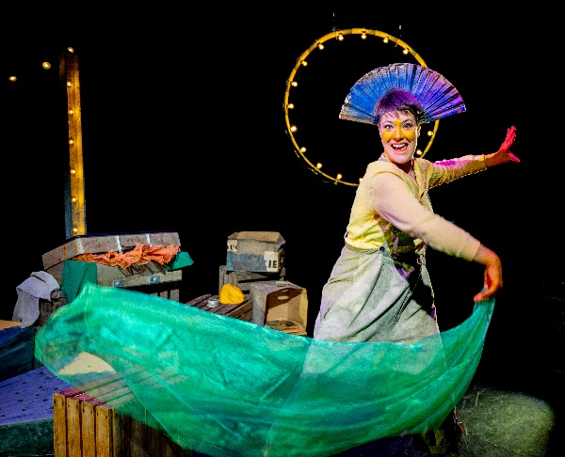 | The peacock tells Duckie’s about his future.  The peacock tells Duckie thatshe must be himself, and not pretend to be someone else.
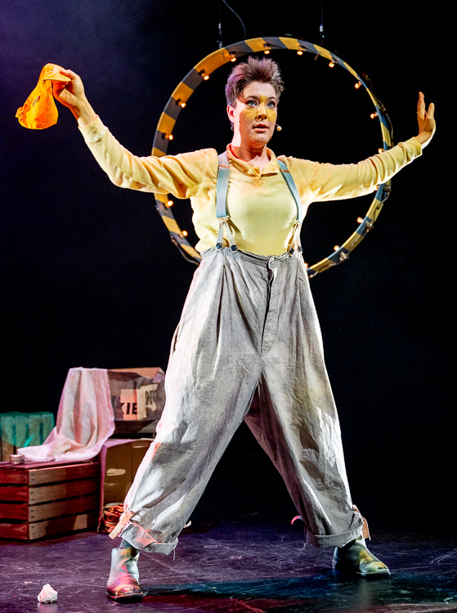 | Paula takes off the fan-hat and becomes Duckie again.  Duckie finds some seals, slapping their flippers. Duckie sees the seals throwing balls to each other.  The narrator asks the audience to pretend to throw balls as well.  You can throw a ball onto the stage but if you do not want to, that’s ok.
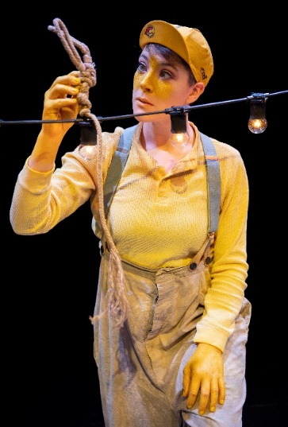 | This is a mouse.  The mouse says the seals, flamingos and the lion should stop being mean to Duckie.  The mouse sings a song, telling Duckie that nothing will hurt him while the mouse is around..
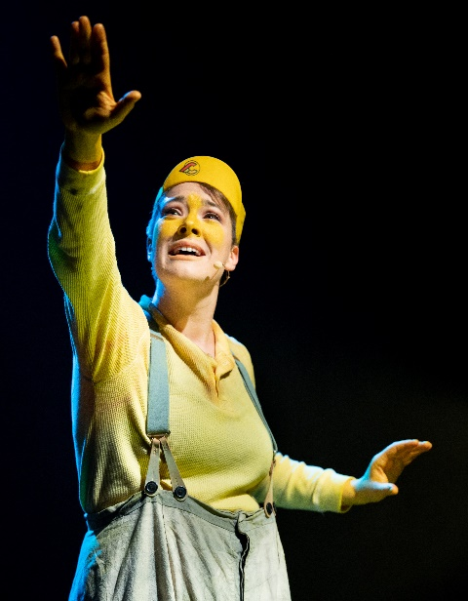 | The mouse disappears and Duckie sees some elephants, practising acrobatics. This means the elephants are practising lifting each other up and jumping.  Duckie tries to join in.
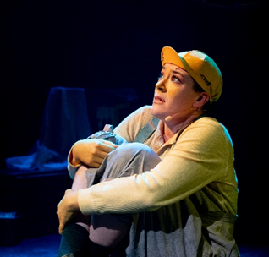 | We start to hear lots of different voices shouting at Duckie.  This part of the show is loud.  The voices say Duckie is too small, too big, too yellow and that he does not fit in.
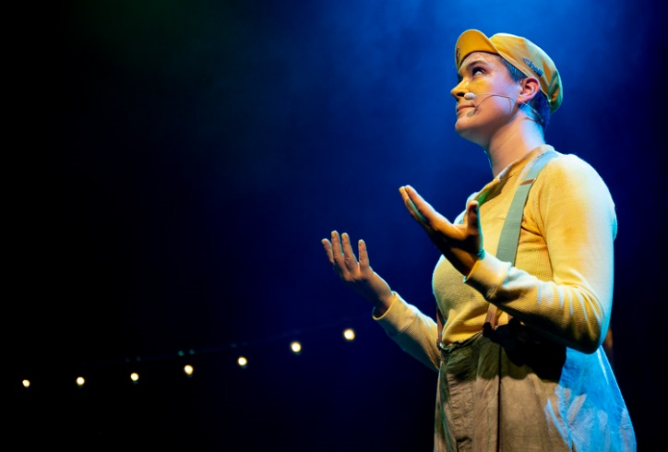 | Duckie sings a song. The other animals realise he can sing very well.
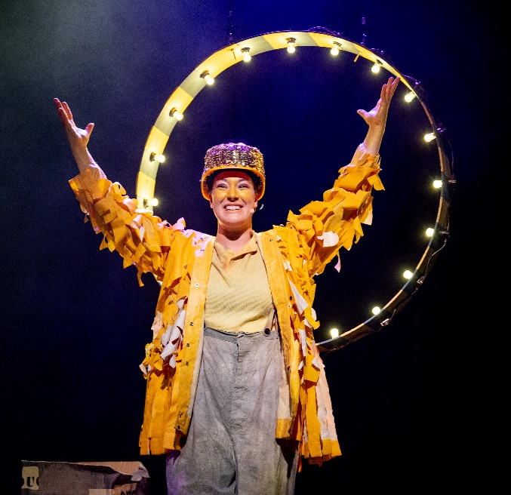 | We hear the voice of the circus manager asking Duckie to sing in the circus.  Duckie is very happy and puts on a beautiful yellow costume with a sparkly yellow hat.
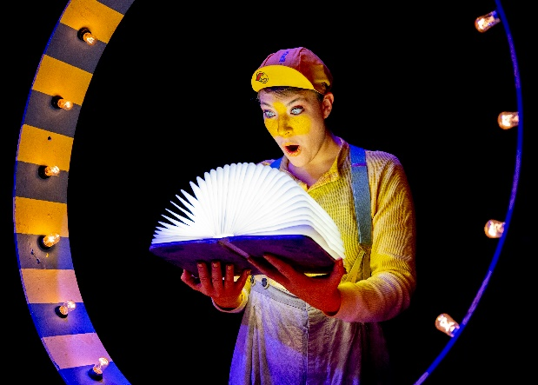 | Duckie picks up the brightly lit book again. The narrator tells us that Duckie now knows he is special and he will love himself just as he is.  The End.

