Psychodrama – Pre show Information

This information is to help you decide if Psychodrama is for you. Content notes, including what happens in the show, are further in the document.

The Space

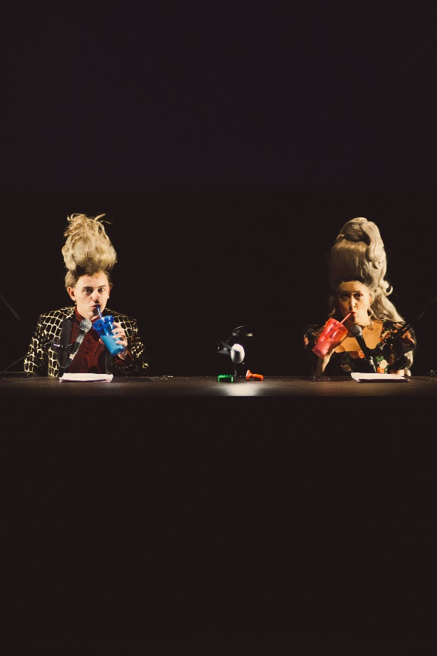

The space is dark. At the centre of the stage is a table with two microphone. The performers sit behind the table for most of the show. To the right is a jukebox.

The Performers
- The performers are:

Christopher Brett Bailey
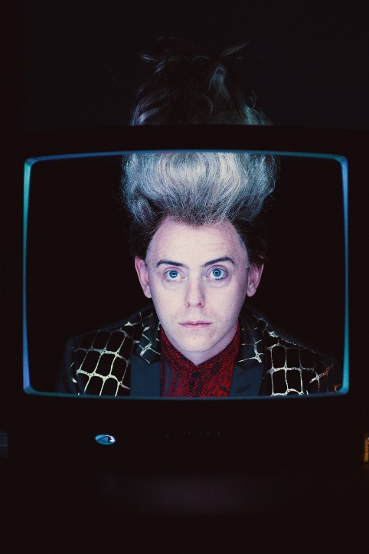
iara Solana Arana
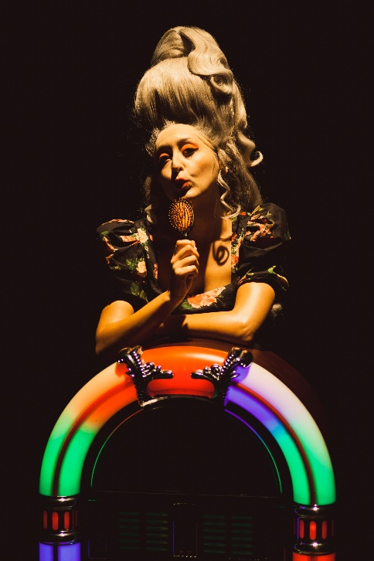

Lighting and Sound
- There will be haze in this performance
- There are no strobes or rapidly moving lights in this performance
- There is complete darkness for a little over 2 minutes towards the end of the show
- You listen to the performance through headphones
- Taking off the headphones is like taking a break from the show
- The performance is generally loud. If it is too loud you can ask the welcome team for help making it quieter
- The entire performance has music underneath the performers speaking. But there will be captioned performances

Participation
- There is no audience participation

Content Notes
In Psychodrama, two people, Chris and iara talk into microphones. They tell you to imagine things. First, they describe going through a desert that might be from the Roadrunner cartoon. Chris talks about watching cartoons as a kid. They describe a war. Then they describe a diner and having sex in the diner. Then Chris talks about Popeye. iara talks about true crime. The story changes to a love story. Then they talk about going to the Magic Kingdom. They talk about going back to the diner. They describe a beautiful place. They talk about how important stories and imagination are.
Psychodrama is about imagination, and how the stories we hear in childhood shape our imaginings. There is no violence or sex depicted, but the show will encourage you to imagine a lot of sex and violence. The way the sex and violence is described is very over the top and it doesn’t sound real. There is one short moment of comically simulated oral sex.

Access Information
- The performance is 75 minutes long
- The performance space has step-free access via a lift
- There will be a captioned performance on 8 April
- All performances are Relaxed this means you can move or make noise if you need to and can go in and out of the performance space
- Latecomers will be permitted
- There is an accessible toilet on every floor of the building
- There is a chill out space outside the performance space that is available anytime the building is open

