He’s Dead – Pre show Information

This information is to help you decide if He’s Dead is for you. Content notes, including what happens in the show, are further in the document.

The Space
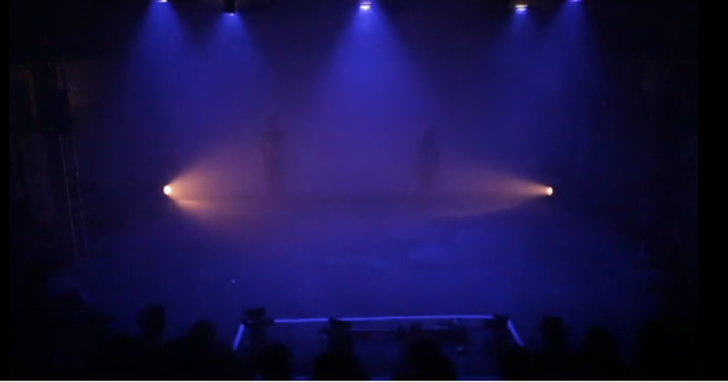

The stage is blank. There will be projection on the back wall of the theatre.

The Performers

The performers are:

Eve Stainton

Blue Makwana

Gareth Chambers

Malik Nashad Sharpe

Lighting and Sound
- He’s Dead is a dance piece with about eight minutes worth of singing and speaking that’s essential to the show
- The rest of the music has lyrics but they are atmospheric not intended to convey meaning
- The entire show is very loud
- There will bright flashing lights through the whole performance
- There are a few minutes of complete blackness
- There is a lot of haze throughout and smoke in the performance

Participation
- There is no audience participation in the show

Content Notes
He’s Dead is a dance show. The show asks if Tupac was depressed. But there’s no answer to this question and the dance is about how we live with not knowing. Fake guns are used in the piece. There is reference to suicide but nothing explicit is shown.

Access Information
- The performance is 45 minutes long
- There is no interval
- The performance space has step-free access via a lift
- All performances are Relaxed this means you can move or make noise if you need to and can go in and out of the performance space
- There will be a sensory adaptive performance on 31 March at 7:30pm. This means the lights and sound will be changed to make it friendly to people with sensory sensitivities
- There will be a captioned performance on 1 April at 7:30pm. This means the music will be described and the essential words will be shown on a screen
- Latecomers will be permitted
- Ear defenders are available for anyone who might find these useful
- There is an accessible toilet on every floor of the building
- There is a chill out space outside the performance space that is available anytime the building is open

