Grin – Pre show Information

This information is to help you decide if Grin is for you. Content notes, including what happens in the show, are further in the document.

The Space
The stage is covered with small piles of silver tinsel.

The Performers
- The performers are:

Kemono L. Riot
Divine Tasinda
[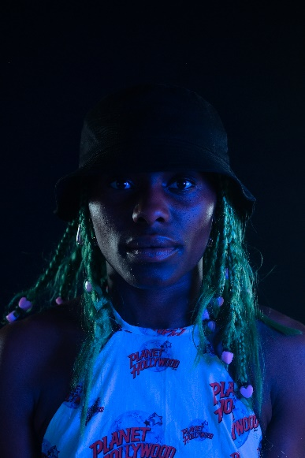
There are videos to help you get to know the performers and people who worked on Grin better:
Meet Kemono L.Riot - https://vimeo.com/583616076
Meet Patricia Panther - https://vimeo.com/583614768
Meet Divine Tasinda: https://vimeo.com/583611123

Lighting and Sound
- The entire show is loud
- There will bright flashing lights through the whole performance
- There is haze
- There is complete darkness a few times in the performance. It is always brief (just a few seconds)
- No one speaks in the performance

Participation
- There is no audience participation in the show

Content Notes
Grin is a dance piece. There is no clear story line and the relationship between the two performers changes throughout the show.
Grin is about caring for each other, hope, generousity and about resisting the story that African and Carribean dance is very sexual.
Access Information
- The performance is 45 minutes long
- There is no interval
- The performance space has step-free access
- All performances are Relaxed this means you can move or make noise if you need to and can go in and out of the performance space
- The performance will be audio described by Elaine Joseph on 26 May
- Latecomers will be permitted
- Ear defenders are available to borrow from the box office for anyone who might find these useful
- There is an accessible toilet on every floor of the building
- There is a chill out space outside the performance space that is available anytime the building is open

