Community Callout
Easy Read Guide

Summary
 | This is a callout for young people aged 18-29 to put on an event in our building.
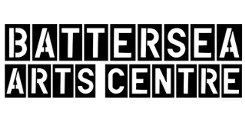 | Battersea Arts Centre is giving money for young creatives to do events as part of our Homegrown series.
 | This is an easy read guide to tell you about this opportunity and how to apply

What is a community callout?
 | Battersea Arts Centre is organising events for young people in April called Homegrown.
 | This callout is for people to submit ideas for an event they want to host in our building. This could be a workshop, live music, ,dance battle, exhibition , spoken word, audio installations and other types of events.
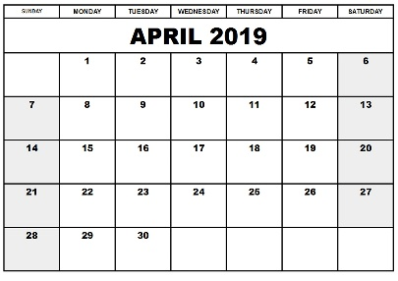 | These different types of event will happen in April.
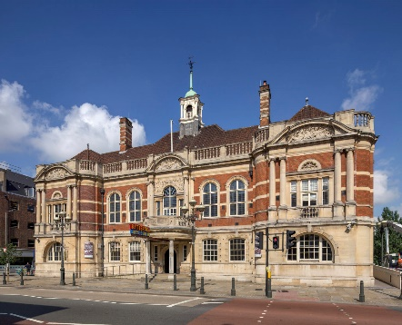 | The events will happen in our building.

Should I send my idea for the community callout?
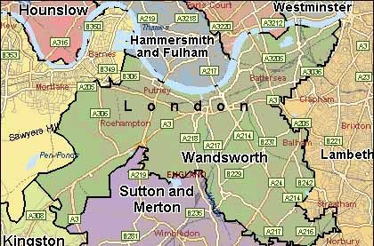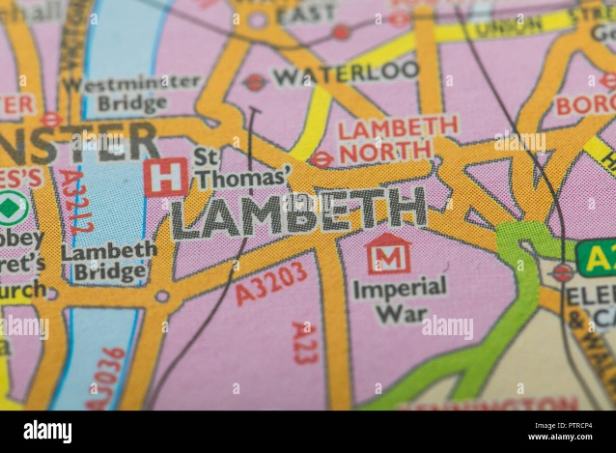 | You can apply if you:  - Are living in Wandsworth or Lambeth  - Aged 18-29
You should apply if you have an idea for an event that:
- You are able to present in our building in April
- Is for other young people.
- Brings people together.
- Is not a theatre show.
- Can be presented this Spring.
You will receive support from our team.

You will receive £500 to £2000 to do your event.

How do I apply?
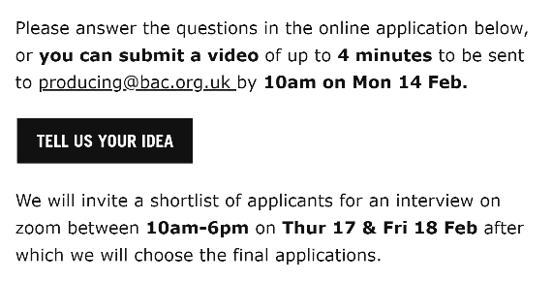 | You can apply by filling out the word form at the bottom of this page: https://bac.org.uk/create-with-us/community-callout/  To get the word form click on the button that says ‘Tell us your idea’  If you need support in filling out the form please email christieh@bac.org.uk.  Please send us your idea before 14 Feb.
There will be interviews if we want to hear more about your event.

The interviews will happen Thursday 17 February and Friday 18 February between 10am – 6pm.

If you have any access requirements for the interview please let us know in your application.
 | The deadline to apply is 10am, 14 February.
The form will ask you for:
- Full Name *
- Email *
- Postcode *
- Tell us about your event (up to 300 words) *
- Who is your event for? (up to 150 words) *
- Tell us about your experience running events (up to 150 words) *
- Who else is working with you and what is their experience in running events? (up to 150 words) *
- How does this opportunity benefit you and your experience? (up to 150 words) *
- Dates: Is it possible to run your event between Mon 4th - Sat 9th April? *
- If you ticked no - please outline possible timeframe for your event.
- Budget: Please outline the fees you will pay to those involved. *
- Budget: Will your tickets be free or charged? *
- What (if any) extra support will you need from BAC? (up to 100 words) *
- Are you available for interview between 10am & 6pm on Thurs 17 & Fri 18 Feb? *
- Please outline if you have any access requirements for the interview.

