Uncanny Valley – Pre show Information

This information is to help you decide if Uncanny Valley is for you. Content notes, including what happens in the show, are further in the document.

The Space
The performance will take place in the Council Chamber. There will be a chair on the stage that the animatronic Thomas Melle will sit in. There is a screen beside him.

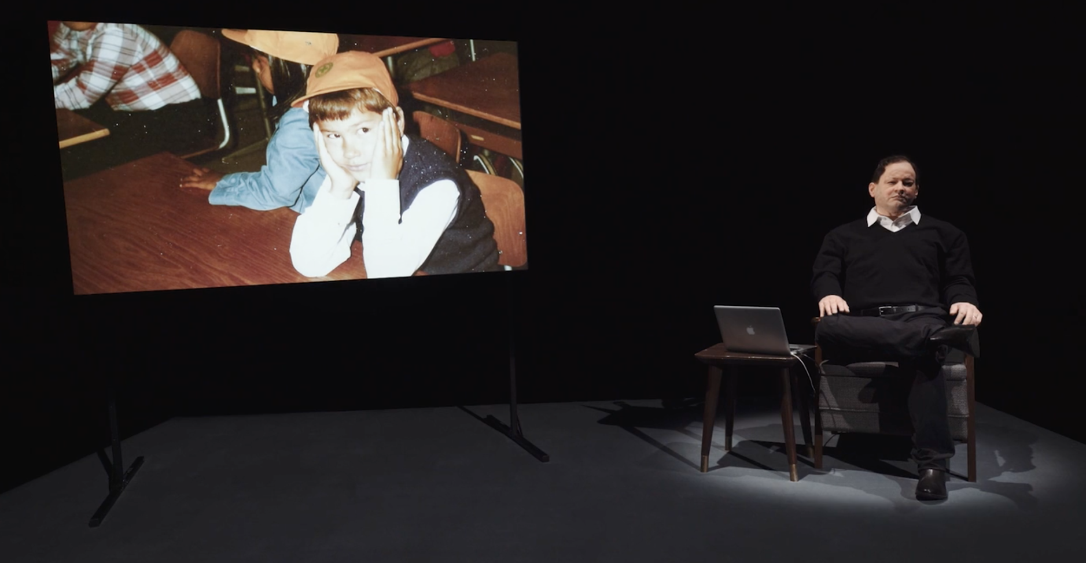

The Performers
The performer is the animatronic Thomas Melle
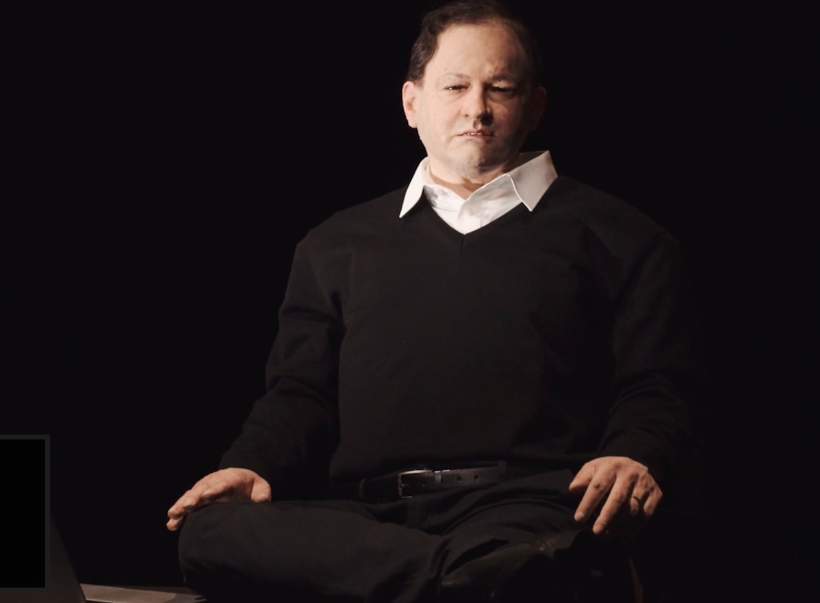

Lighting and Sound
- There will not be haze in this performance
- There are no strobes or but there are some flashing lights
- There is one minute of very loud music when the animatronic Thomas asks the light to dance
- There is a minute of darkness
- Sometimes there is music underneath the animatronic Thomas Melle speaking, there will be a captioned performance on 24 February if this will make understanding the show difficult for you

Participation
There is no audience participation
Content Notes
- In the performance the animatronic Thomas Melle gives a lecture about the uncanny valley. This lecture talk about two people, Thomas Melle and Alan Turing. Thomas Melle is a writer and a theatre artist. Thomas Melle has bipolar disorder. Alan Turing was mathematician who invented an early computer. Turing was gay and was forced into treatment for this. Turing killed himself. The play discusses how Turing killed himself but does not show this.
- Throughout the show Melle is clear that he does not consider his bipolar disorder positive. For example, he calls himself ‘psychologically damaged’
- Early in the performance Melle also uses ‘autistic’ to mean being alone

Access Information
- The performance is 60 minutes long
- The performance space has step-free access via a lift
- There will be a captioned show on 24 February at 7:30pm
- All performances are Relaxed this means you can move or make noise if you need to and can go in and out of the performance space
- Latecomers will be permitted
- Ear defenders are available to borrow from the box office for anyone who might find these useful
- There is an accessible toilet on every floor of the building
- There is a chill out space outside the performance space that is available anytime the building is open

