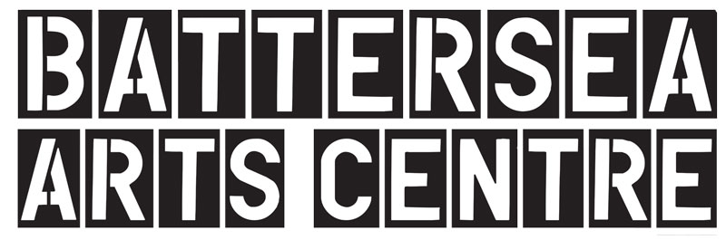

Call Out:
Looking for new producing partner to join a National social change Project

Introduction:

Moving Roots is a collective of arts organisations; Battersea Arts Centre, Common Wealth Theatre based in East Cardiff, The Old Courts based in Wigan and Jumped Up Theatre based in Peterborough.

We believe in co-creation as a mechanism for direct and impactful social change.

We’re looking for an ambitious, grass roots organisation to join the network from January 2022 until July 2023 to collaborate with our communities and deliver two ambitious co-created projects with live performance at its heart.

We are specifically looking for an organisation with experience of co-creation, working in a town or city with low levels of arts investment.

The project is funded by Esmee Fairbairn Foundation and Garfield Weston Foundation and provides a £45k producing fee across 18 months, plus budget for activity. Activity will begin in January 2022 and end by July 2023.

ABOUT MOVING ROOTS

It’s incredible being part of Moving Roots, it’s enabled us to bring much-needed resource, creativity, and energy into our community. It’s been a catalyst to us producing outside of Common Wealth, supporting work and artists that align with our values and core beliefs. We’ve been able to establish a sounding board that supports and helps shape the mission, bring world-class artists & shows to our community and explore the notion of co-creation and the future of touring. It feels like we’re building new models, new ways of collaborating – ways that are more equitable, that value people, places and have social change at the heart. – Rhiannon White, Artistic Director of Common Wealth
The aims of the project are:
- For local people have increased agency and take an active role in shaping creative activity in their hometown.
- That partner locations are perceived locally and nationally as artistically vibrant places.
- To prove that co-creation works as a mechanism for impactful social change in towns and cities.
Our Moving Roots manifesto and our definition of co-creation can be found on our website here.
“It isn't about organisations 'reaching out' to people in underserved communities - it's about bringing people together for a common creative purpose, as equal partners, as joint collaborators, as 'co-creators' in the deepest sense of the term. These ambitious new partnerships and ways of working have a simple idea at their heart: that it is possible for us all to achieve a fairer, more inclusive and more vibrant cultural future.” - Tarek Iskander, Artistic Director & CEO, Battersea Arts Centre

From 2019-2023 the project will programme three pre-existing co-created live shows. The new partner will join for the final 18 months of the project to deliver the second project, confirmed as Epic Fail by artist Kid Carpet. The project will work with year 5 pupils in schools to re-imagine their idea of failure, and together, create a live show in the schools. This activity will be delivered between January- July 2022. The third project is yet to be programmed, and we expect the new partner to feed into this decision.

The first show on the project was Rent Party by artists Darren Pritchard and Stuart Bowden. Each partner re-imagined the critically acclaimed show ‘Rent Party’ with a local cast throughout 2021; passing the mic around working class communities and platforming the incredible talents of professional, often unheard artists in their area.

There is a delivery budget of around £25k per partner per project. Partners will be producing these projects in collaboration with existing local charities, services and other organisations. It’s important that the project doesn’t sit in a vacuum, and that its benefits are felt broadly in each place we tour it to. There is also a fundraising target of £14k towards the core costs of the project expected from each partner before the end of the project.

As well as the core project activity the project supports partners to go see new work, manage their own local sounding board and upskill local writers to evaluate the project.

What we’re looking for:
- We are looking for an organisation who is passionate about and has experience of co-creation
- We are looking to work specifically in a town or city where there is currently a low level of arts and cultural investment, and ideally, outside the places we’re already working in (Wigan, Peterborough and East Cardiff).
- We encourage applications from different sized organisations but it is unlikely we will select an NPO organisation.
About You
- You will have experience of delivering ambitious community focused projects and are passionate about supporting the future opportunities of where you’re working
- You will be ingrained in your local community; you will have an understanding of the strengths and challenges of where you’re working, and have active relationships with local people, groups, organisations
- You could be someone who identifies as a theatre producer, but could also be a community leader who believes in the potential of creativity to raise aspirations and change the place they live.
- You are inspired to take creative risks, want to work collaboratively as a network and be excited about learning and developing new ways of working
- You’re passionate about live performance and theatre

The Application Process

Stage 1

If you are interested in applying, please submit an application by 9am Monday 6 December.

We will be hosting the information drop in sessions over Zoom for people to hear about the project, meet some of the current partners and ask questions.
Drop In Session Dates:
Friday 19 November, 2-3pm
Tuesday 30 November, 10-11am

If you’re interested in being part of one of these sessions please email christieh@bac.org.uk to sign up.

Stage 2

We aim to respond to shortlisted applications by Friday 10 December. We will invite a shortlist of applications for interview w/c Monday 13 December.

Interviews will be over zoom for 1 hour. Interview questions and any tasks will be sent ahead of the interview.

We aim to select a partner by w/c 20 December.

For any immediate questions about the project or if you need support in making your application please contact Christie Hill on christieh@bac.org.uk

Application questions (tbc)

- What is your current output/programme? Where does this activity take place? (150 words)

- What is your understanding of and experience of co-creation? (150 words)

- How would you describe the community around you, your place within it? (150 words)

- What excites you about the Moving Roots project? (150 words)

- What is your experience of delivering ambitious creative activity? (150 words)

