Little Wimmin – Pre show Information

Access Information
- The performance is 2 hours long including a fifteen minute interval
- The performance space has step-free access
- There will be a BSL interpreted performance on October 23rd
- The script is available by request. To request the script please email access@bac.org.uk
- All performances are Relaxed this means you can move or make noise if you need to and can go in and out of the performance space
- Latecomers will be permitted
- Ear defenders are available to borrow from the box office for anyone who might find these useful
- There is an accessible toilet on every floor of the building
- There is a chill out space outside the performance space that is available anytime the building is open

Lighting and Sound
- Music is used throughout the performance, this includes classical, synthesizer, pop and drone sounds
- A lot of the music will be loud
- There is a sudden loud thunderclap
- Towards the end of the show, after the performers do a dance in orange cage skirts 100 limes will fall from the ceiling. This will be very loud.
- There will be a slow flashing light in the second half of the show
- There will be a lot of haze at the opening of the show

Participation
- There is no audience participation

Content Notes
- The show begins with 5 performers seemingly floating onstage. They give a detailed and funny description of the show that is about to come. They talk about the themes of the work in a funny way. This lasts 15 minutes. Then there is a break.
- The second half starts as a traditional adaptation of Little Women by Louisa May Alcott. It follows the lives of four young sisters Meg, Jo, Beth and Amy in 1860s Massachusetts. It’s extremely earnest. Slowly the show starts to get weirder and weirder.
- The sisters attend a ball where they perform a contemporary dance to classical music. This turns into a raucous hen party with sashes and an ice sculpture shaped like a giant penis. The Christmas tree in the living room comes alive, tears the show to pieces and performs a lip sync number to Driving Home for Christmas.
- The sisters turn into a giant glove, a giant nose, a horse in a suit and a sack of mucus who together become the Christmas tree’s backing dancers. One performer sings a song on a vibrating plate holding a jelly while the others strike the set. Then they perform a dance inspired by wind turbines.
- 100 limes fall from the ceiling and the cast wheel on an industrial juicer and juice the limes.
- Finally they make a giant margarita in a giant cocktail glass and down the whole thing through giant straws.

Does anything particularly upsetting or potentially traumatic happen?
- There is the performance of drinking alcohol - the actors do not consume real alcohol.
- There is a dramatic over-the-top death scene. This is not real.
- There is a point where a character goes into heavy labour with screaming and gives birth to two babies made out of cloth.
- Some of the music/soundscapes create an ominous unsettling feeling

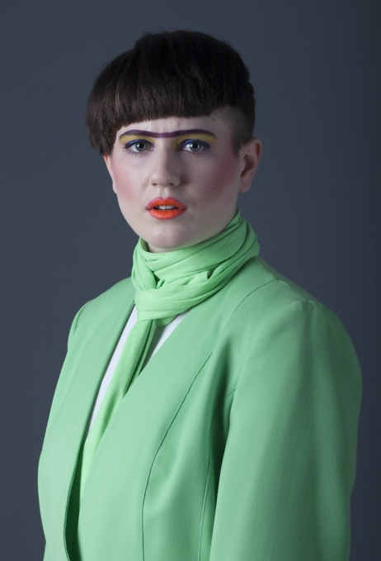
The Performers
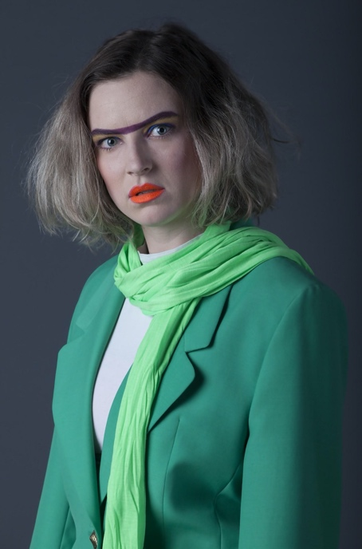
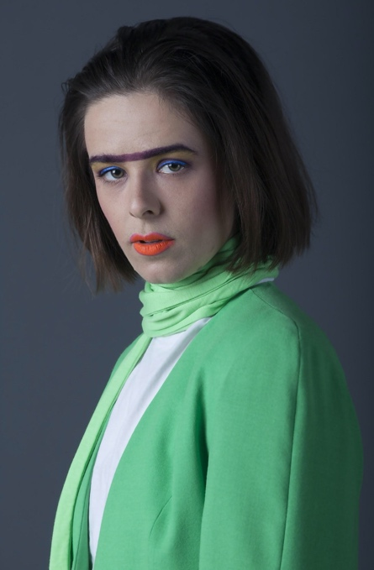

Rachel Porter
Alice Roots
Rachel Gammon

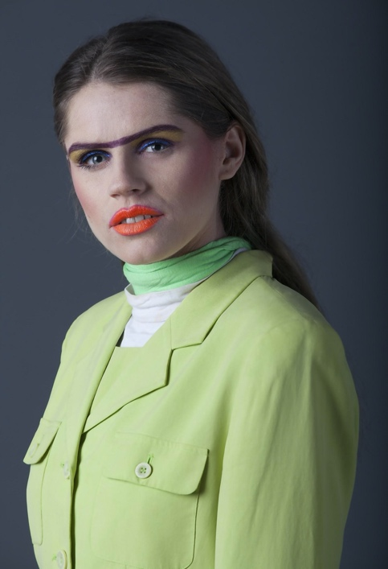
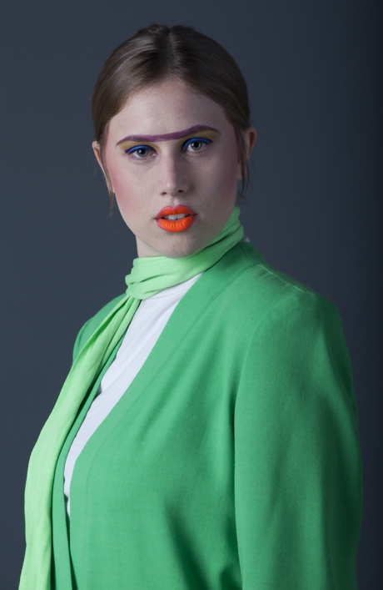
Sarah Moore
Suzanna Hurst

The Space
This is what some of the show will look like:
