Sleeping Beauty and the Beast Visual Guide
This is a visual guide to Sleeping Beauty and The Beast by the Sleeping Trees.

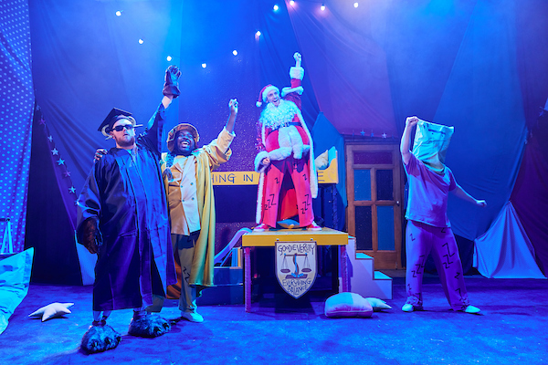 | Sleeping Beauty and The Beast is a panto. This means that Sleeping Beauty and The Beast is a funny play. It has fairy tale characters, songs and villains. Villains are people who like being bad. In a panto you can talk to the performers and characters and they will talk back.
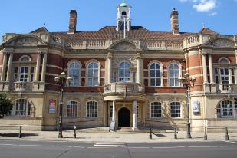 | It takes place at Battersea Arts Centre. If you want more information about Battersea Arts Centre look at our visual guide.
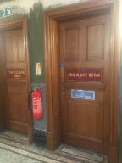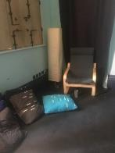 | The performance is a relaxed performance. This means you can move and make noise. You can leave the show and come back in at any point. There is a chill out space on the same floor as the performance.
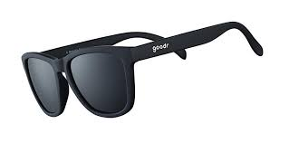 | There will be lots of bright lights and really fast lights. The sensory adaptive performance won’t have those bright and fast lights. If you don’t like bright lights you can wear sunglasses.
. The whole show is loud. There are some doorbells in the first five minutes that are very loud. There are some monster roars after the interval that are very loud.

The sensory adaptive performance will be quieter. If you don’t like loud noises you can wear ear defenders.

Who are the Performers?
All of the performers are in a group called the Sleeping Trees. All the performers will play lots of different people.
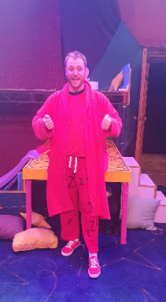 | This is John. He plays Captain Hook and Santa Claus
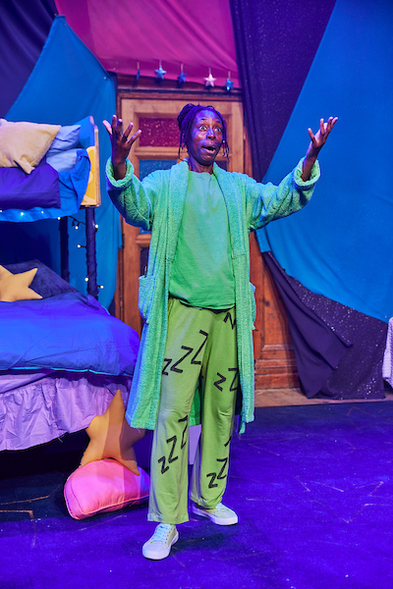 | This is Jules. She plays the Wicked Stepmother, King Rat, the Mummy, Ofsted, Gaston from Sleeping Beauty, and Sleepy the Dwarf
 | This is Jamal. He plays Belle
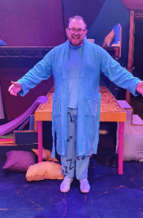 | This is Josh. He plays the Beast.
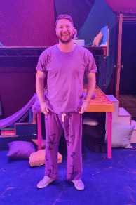 | This is James. He plays the ghost, Frankenstein, and Detective Sleeping Beauty

What happens?
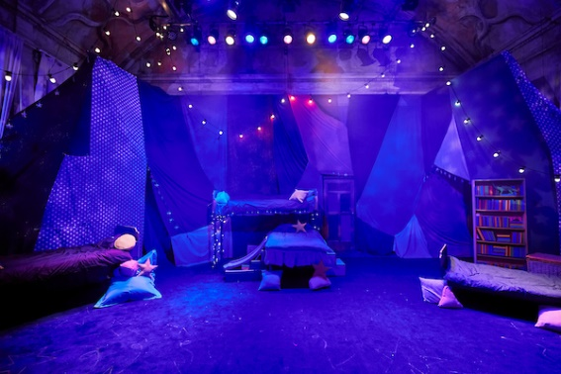 | - Sleeping Beauty and the Beast starts in a bedroom.
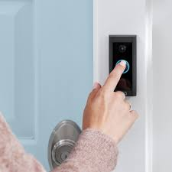 | There are a lot of loud doorbell sounds in the start of the show as everyone comes in.
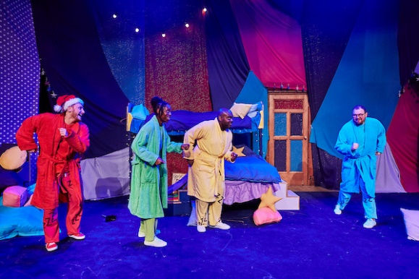 | John, Jules, Jamal, Josh and James are all here for the Sleeping Trees Christmas slumber party.
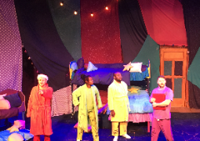 | James has written a play. James wants to do serious theatre. But John, Jules, Jamal and Josh want to do a fun panto with songs, silly characters from fairy tales and good and evil.
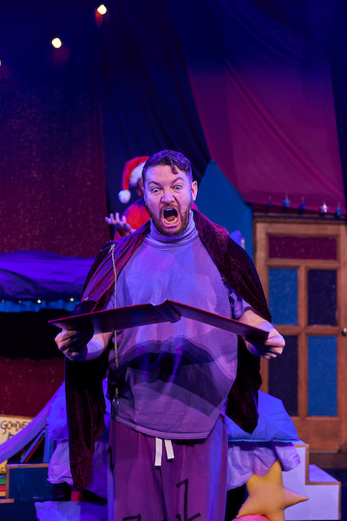 | The script disappears. James is very upset.
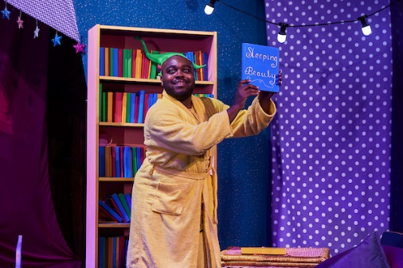 | Jules, John, Jamal and Josh suggest they make up a story.
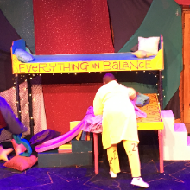 | The story they make up is about the Goodie-versity.
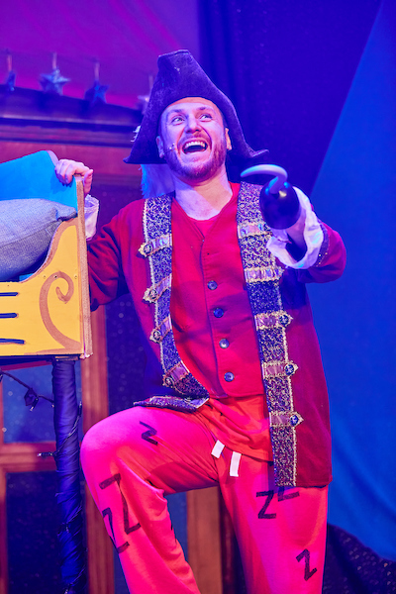 | The Goodie-versity helps villains from stories become good. People like Captain Hook, Frankenstein, King Rat, The Mummy and the Troll go there.
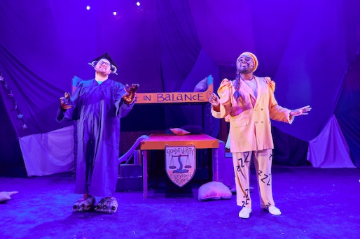 | Belle and the Beast are the head teachers at Goodie-versity
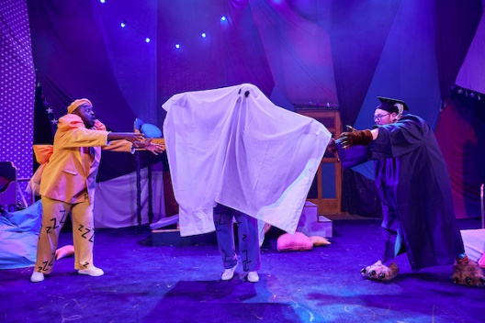 | Jamal, John, Jules and Josh have to convince James to pretend to be a ghost. James doesn’t really want to be a ghost or tell the story about Goodie-versity.
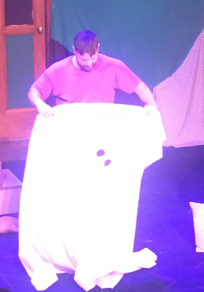 | All through the show James will stop. Then Jamal, John, Jules and Josh have to talk James into doing the show.
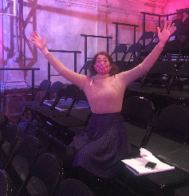 | One of the ways the Goodie-versity makes people good is through the reverse boo. Belle and the Beast will ask you to raise your hands and chant ooooob.
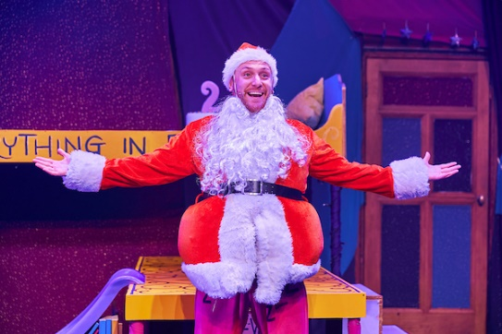 | Today is Gooduation Day. This means students of the Goodie-versity graduate. When students graduate they go on Santa’s good list and get presents.
 | The Beast suddenly falls asleep. Belle can’t wake him. She props him up so the Gooduation can happen.
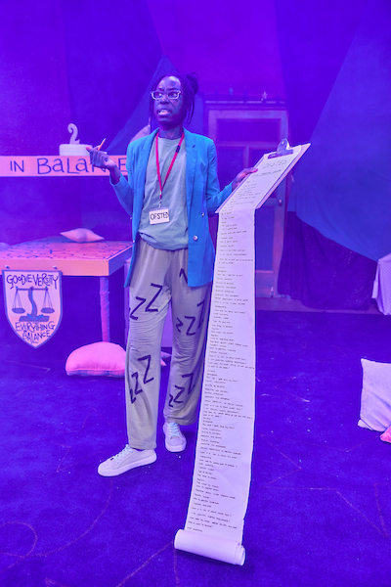 | Ofsted comes. Ofsted inspects schools and tells them if they are good. If the schools aren’t good Ofsted closes them.. Ofsted says that she needs all the villains to graduate for Goodie-versity to be a good school.
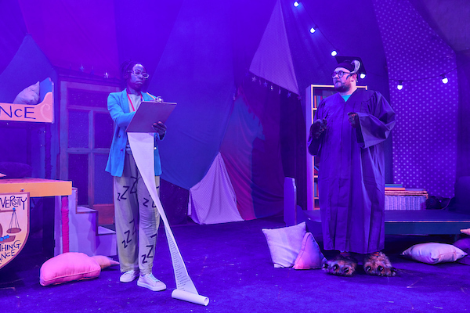 | Santa tells Ofsted that there’s a missing student, The Big Bad Wolf. Ofsted realises that the Beast is asleep. Ofsted stops the Gooduation. Everyone has to wake up the Beast and find the Big Bad Wolf. If they don’t Goodie-versity will have to close!
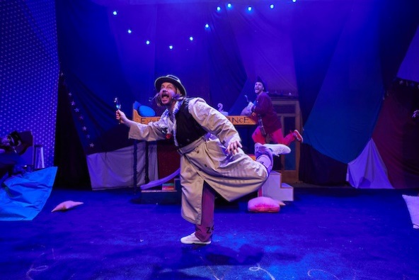 | Belle calls Detective Sleeping Beauty to solve the mystery of why the Beast is asleep.
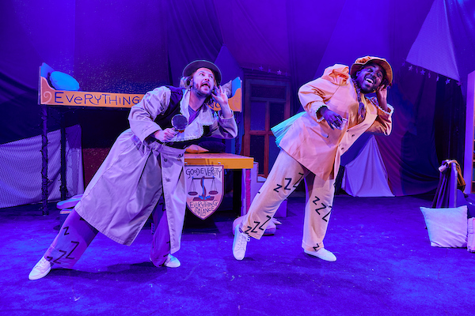 | Detective Sleeping Beauty talks to lots of characters. Detective Sleeping Beauty looks around and discovers sleeping potion in some cake that the Beast ate.
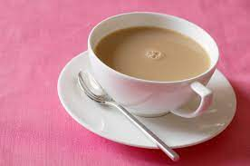 | There is the interval. This means you can take a break.
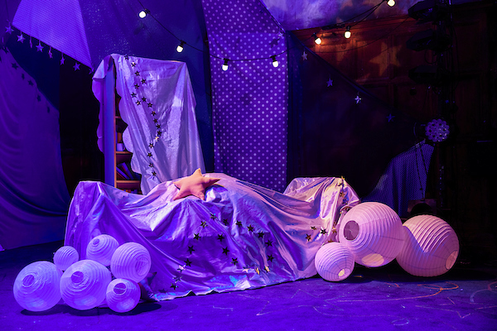 | Beauty takes Belle to Dreamland to look for the Beast. Dreamland is where you go when you sleep.
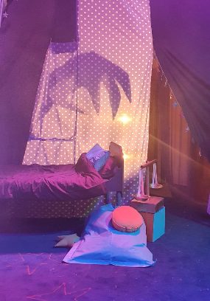 | The Sleep Monster lives in Dreamland and will make loud, scary monster noises.
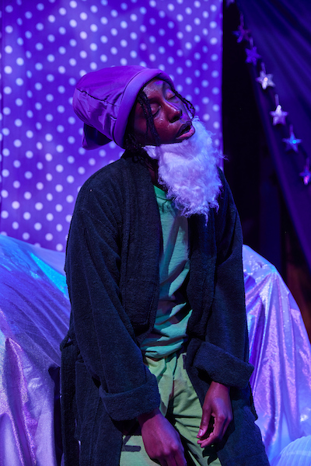 | The Beast wakes up in Dreamland. The Beast meets Sleepy from Snow White and the Seven Dwarves. Sleepy explains that the Beast needs to find the right wake up spell.
 | The Beast meets Santa who also ate the sleeping potion. If Santa doesn’t wake up Christmas is cancelled for one thousand years!
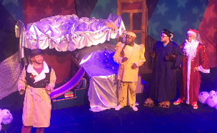 | Belle and Beauty find the Beast and Santa. Beauty reveals that she gave the Beast and Santa the sleeping potion. She is a villain and wants all the villains at the Goodie-versity to be bad again.
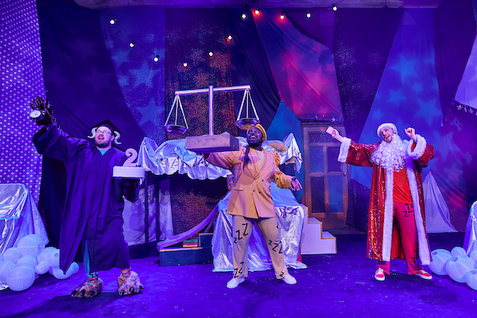 | Beauty wakes up and disappears. Santa, the Beast and Belle have to figure out the wake up spell so they can stop Beauty.
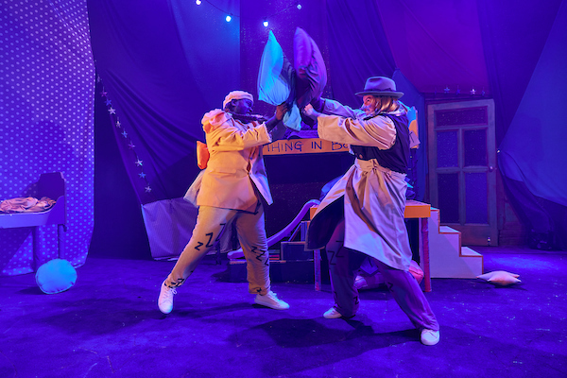 | Santa, the Beast and Belle wake up at Goodie-versity. They have to pillow fight Beauty.
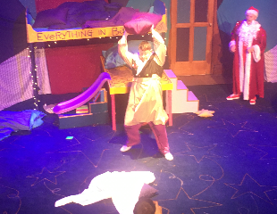 | In the fight James, who is pretending to be Detective Sleeping Beauty, is really mean to the ghost.
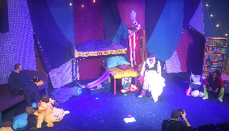 | Everyone stops. James finds his missing? script.
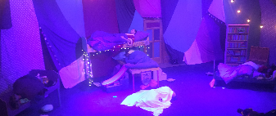 | No one wants to keep going. They all go to bed.
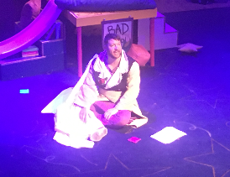 | James says sorry to the audience for stopping the show. Then he has an idea. He wakes everyone up so they can finish the story.
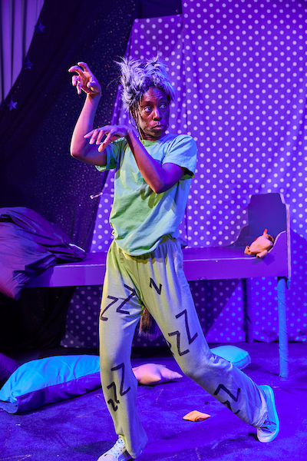 | Santa, the Beast, Belle and Beauty start fighting again. But then the Big Bad Wolf appears.
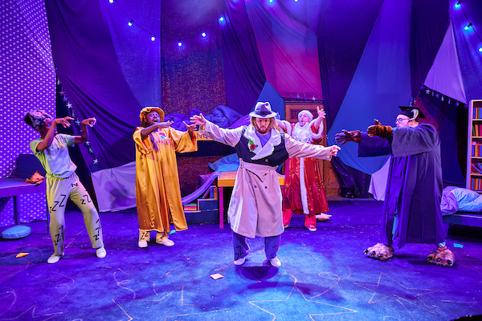 | Belle, the Big Bad Wolf and the audience reverse boo Beauty to turn her good.
 | The Big Bad Wolf, the ghost and Sleeping Beauty all graduate. Ofsted will let Goodie-versity stay open. Everyone sings and is happy. The end.

