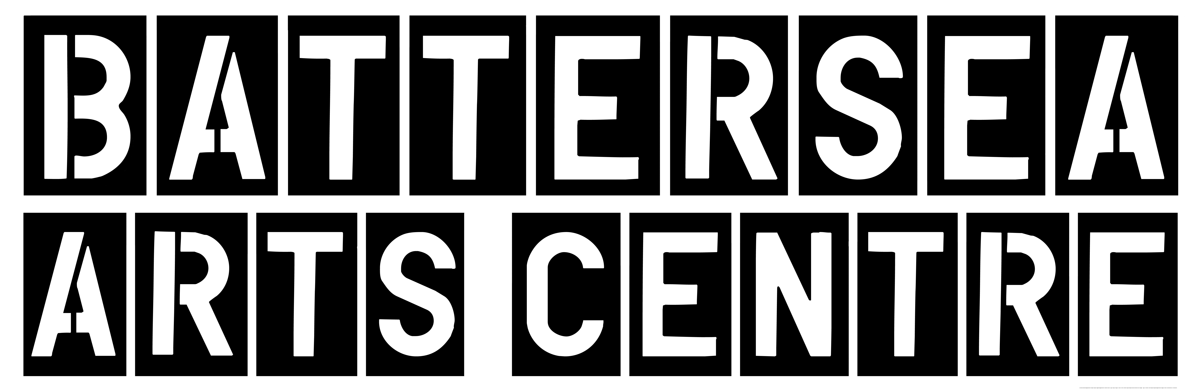

The Members Bar – Technical Specifications
For the attention of your company’s technical team

CONTENTS

Page 1
- Welcome to Battersea Arts Centre
- Parking Restrictions

Page 2
- Unloading and Access
- Overview and Plan

Page 3
- Lighting
- Audio
- Network
- Access Equipment
Page 4
- Effects and Licencing
- Dressing Rooms, Storage and House Keeping
- Staffing
Page 5 & 6
- Photographs

CONTACTS
Production Manager Chris Randall 020 7326 8253 chrisr@bac.org.uk

Welcome to Battersea Arts Centre

This document contains all relevant technical information concerning the Members Bar. Please make time to read it and ensure all key members of your team do as well.

Any further questions can be discussed in a Production Meeting with us at Battersea Arts Centre (BAC). You can also contact us directly using the number(s) on the cover page.

We’re committed to giving your show and your company the best support possible, therefore we are keen to hear any comments your company might have about this support, or suggestions for improving it.

We hope you enjoy your time with us.

BAC Production and Technical Team

Parking Restrictions

This is dependent on the size of your vehicle.

For anything up to the size of a Luton, we can provide space to the east of our front entrance, at the top of Town Hall Road for unloading. There are also 3 standard parking spaces for longer stays on Town Hall Road. These can be booked for your use prior to your arrival through the Production & Technical team, however these spaces are shared throughout the whole organisation and they are therefore dependent on availability.

For larger vehicles up to a 45ft trailer, we can organise parking suspension at the top of Theatre Street, to the west of our main entrance. Parking suspension is £90 per day and this cost is shared between BAC and the Company.

N.B for smaller vehicles we can occasionally organise space on the pavement in front of our building for unloading only.

If you need to park a vehicle during your stay at BAC, we recommend purchasing a £10 day ticket from the ASDA on Lavender Hill.

ASDA Opening Hours:
Monday-Friday 07:30-00:00
Saturday 07:30-22:00
Sunday 11:00-17:00
*Please note times may change, we recommend checking the store’s website before your arrival.

Unloading & Access
Your load-in route to this venue will be via the main entrance through two sets of double doors, up the main marble staircase and then through the two sets of single width doors on the west side of the first floor foyer, which leads directly into the Members Bar.

Main entrance (minimum dimensions): 1390mm wide, 2220mm high

There is also a lift which serves all floors within the building; the internal dimensions are 1400mm W x 2100 H x 2680 D.

Overview

The Members Bar is a venue within Battersea Arts Centre with a fixed lighting grid (height 4400mm), and a capacity of up to 100 (120 Standing). It is accessed via the main staircase in the foyer area and has single width doors for entrance. It is not a black box space, the walls are painted white and the floor is comprised of wooden parquet floor which cannot be fixed too.
All technical equipment listed below is permanently allocated to the venue. Extra equipment, including lanterns, projectors, screens, extra speakers etc. may be available but only by prior arrangement with the BAC Technical and Production Team.

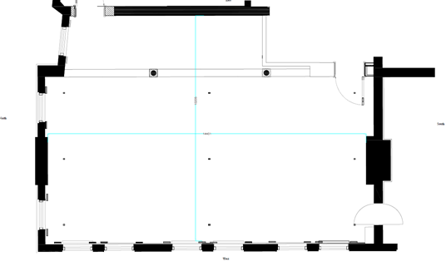

Plan Not to Scale

Lighting

Control: ETC Ion with a 2 x 10 universal fader wing
Diming and Distro: 1 x Avolites Power Cube, which supplies up to 18 circuits at 2Kw (8A) capacity (One circuit used for house lights). Supplied by a 63A 415V 3 phase outlet distributed
Mains: 32A 3 phase socket
General use 13 amp ring main (outlets distributed evenly around perimeter)

Lantern Kit List

All lanterns come with colour frame, hook clamp, safety bond & shutters/barn doors (where applicable)

3 x Source 4 25/50 Zoom Profiles, 750w, 7.6Kg
3 x Source 4 36 degree profiles, 750w, 6.4Kg
6 x Selecon Rama Fresnel, 1.2Kw, 5.3Kg
5 x Strand Cantata Fresnel, 1.2Kw, 5.8Kg
10 x Strand Prelude Fresnel, 650w, 4.5Kg
8 x Par 64 (CP 62 as standard), 1Kw, 3Kg
2 x Selecon HUI Cyc 1 Flood (rigged as house lighting as standard), 800w, 4.1kg

Sound

Distro: 16A Single phase supply
Control: Yamaha TF1 digital mixing console
1 x Tio 1608-D Ethernet stage box
Amps: 1 x d&b D6, 2 channel amplifier
FOH System: 2x d&b E8, 1 x Active Sub
Play Back: Stereo mini jack input to mixer

NB: Microphones, monitors and other audio equipment are available upon request. Please liaise during your production meetings about these requirements. The PA system will be rigged according to the seating rake layout, unless otherwise specified by the company. These placements are designed to give optimum coverage to each seat in the venue and should not be altered.

Network

The main infrastructure of the in-house performance network consists of numerous CAT6A Ethercon outlets distributed throughout the building and terminating into 1 of 2 satellite data cabinets, these are linked via OM3 fibre connections to a main network cabinet on the second floor of the building. The outlets on the first floor of the west wing (including those in the Council Chamber) are served by the West Cabinet; from here it is possible to create a patch into the outlets in the Members Bar.

Ethercon outlets in Members Bar:
4 x Performance use Ethercon outlets, east wall, south corner
4 x Performance use Ethercon outlets (one at grid height), west wall, south corner
4 x Performance use Ethercon outlets (one at grid height), north wall, west corner

Access Equipment

BAC will provide a selection of A-Frame ladders for accessing the grid.

Effects and Additional Licensing

Please let us know well in advance if there are any effects used within the performance such as haze, smoke, or strobe lighting, and if anything is used that requires extra licensing such as smoking, weaponry and pyrotechnics

Dressing Rooms, Storage and Housekeeping

There is a dressing room space which is accessed via the door in the north east corner. This dressing room has mirrors and dressing table on a mezzanine level with WC and shower underneath. The dressing room is not designated to the space so prior arrangement will need to be made with your producer or the technical and production team. This space may also need to be shared with other companies during your visit.
Please try to vacate stage space and backstage areas 20 minutes after each performance with all personal belongings. Re-entry may not be possible after this time so if you’re going to the bar, please take coats, bags etc with you.
Whilst we make every effort to police and secure the premises and venues, thefts do occur.
The company should not leave any venue, control box or dressing room area unattended without informing the BAC Duty Manager. At certain times there may be space available for small items, such as laptops, to be safely stored within the BAC Vault, please liaise with the Duty Manager for more information.
BAC Management and their insurers shall not be held liable in the event of theft, loss or damage to the company’s or individual company member’s property unless BAC Management can be shown to have been negligent.
BAC operates a No Smoking policy. Smoking in the dressing rooms, backstage area or in the theatre space (other than as part of a performance) is strictly forbidden. Smoking during performance must be discussed with your production contact at BAC well in advance of your arrival, as forms will need to be submitted to Wandsworth Council at least 4 weeks prior to your performance.

Staffing

- Additional staff at £15.40 per hr during working hours, double time between 00:00-08:00 minimum call time is 4 hours.
- Rota'd or additional staff at £30.80 per hr at all other times (inc. Bank Holidays)
- Staff taxis after 11.30pm at £30 cost to the company.
- Additional space at an agreed rate where available.
- Additional equipment at an agreed rate where available.
- PAT testing of untested equipment at £10.10 per item.
- Any expenses due to lateness of plans or licensing requirements shall be borne by the company.
- The company shall incur penalties if the design does not facilitate use for other activities and BAC incurs loss of income as a result.
- The company shall be liable for consumption, breakage, loss or theft of BAC’s tools, stock, equipment as a result of the company's or a company member's negligence or neglect and will be charged the full repair or replacement costs.
- The company shall pay for the entire costs of transportation of freight and personnel to and from BAC.

