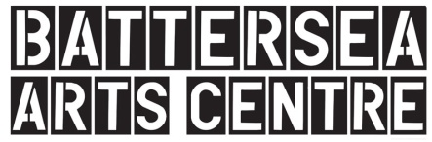
Battersea Arts Centre Visual Resource
This visual resource is for people coming to visit Battersea Arts Centre (BAC). This resource does not have specific information about performances.
Welcome to Battersea Arts Centre. Many different things happen here. People visit to explore the building and the heritage installations; they eat and drink in the Scratch Bar; they play in our indoor play space, The Bee’s Knees; they learn about creativity, they make performances and they see performances.

Getting Here
You can get to BAC a few different ways. You can take a train to Clapham Junction and then walk about 10 minutes. You can take the bus. The 77, 87, 156, 345 and N87 all stop near BAC. You can cycle. There are bike racks in front and behind BAC. You can also drive, but there is not a lot of parking near BAC.
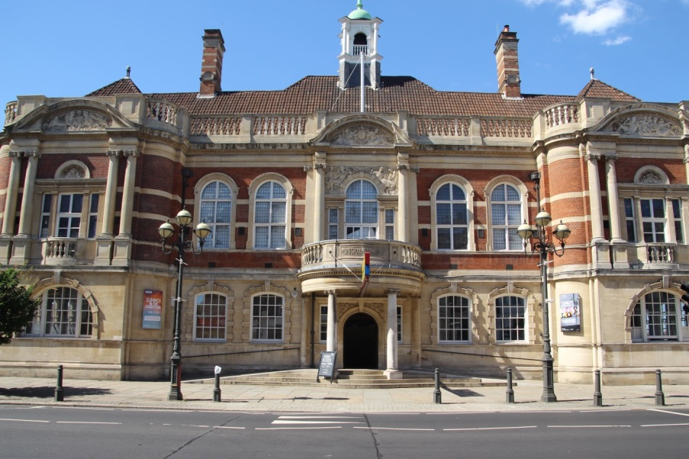
This is the outside of the Battersea Art Centre. This is the main entrance. There are some steps and two ramps.

Just inside the front doors is a map of the building. If you want you can take a copy of the map with you.
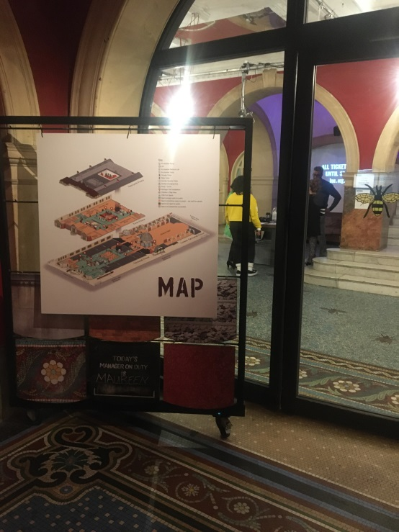
Through the second set of the doors there is a big space with a huge set of stairs. This is the foyer. Depending on when you come, there might be lots of people and lots of noise in the foyer. In the foyer is the welcome desk. The people behind the welcome desk can help you. You can ask them questions.
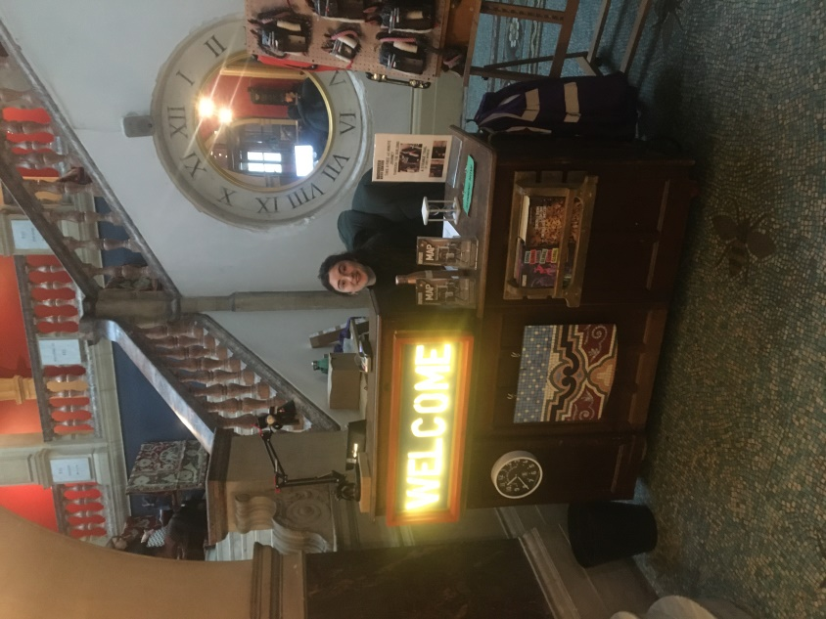
At one end of the foyer is the Scratch Bar. You can buy food and drinks in the Scratch Bar. Depending on when you come there might be lots of people and lots of noise in the Scratch Bar.
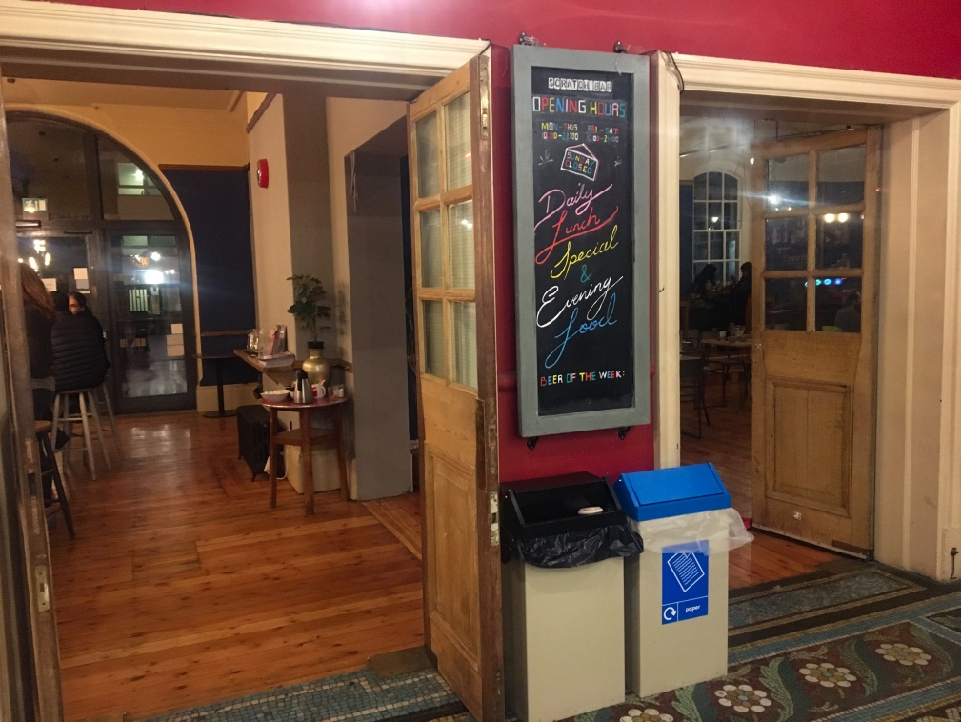
At the other end of the foyer is The Bee’s Knees. This is where children aged five and under and their adults come to play.
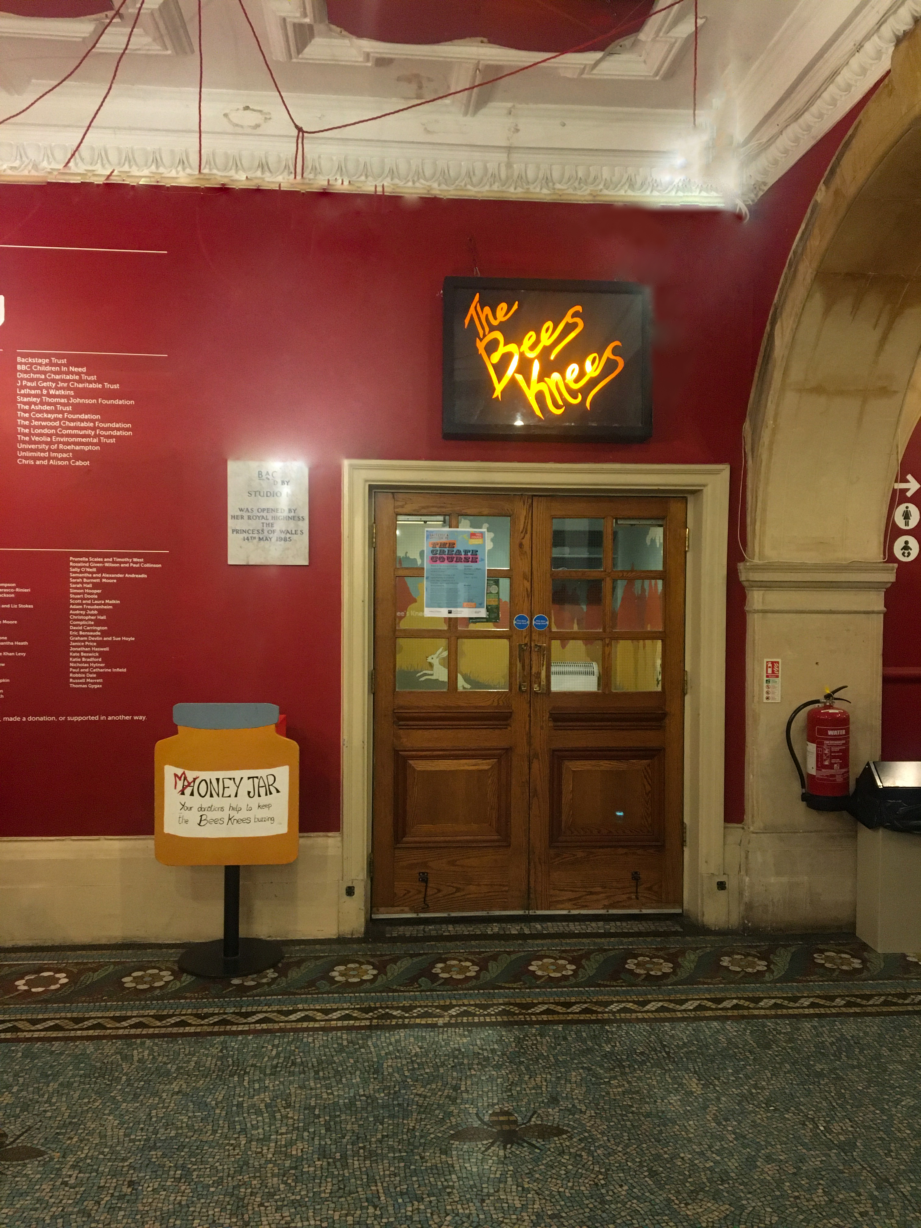
Behind the foyer is the courtyard.
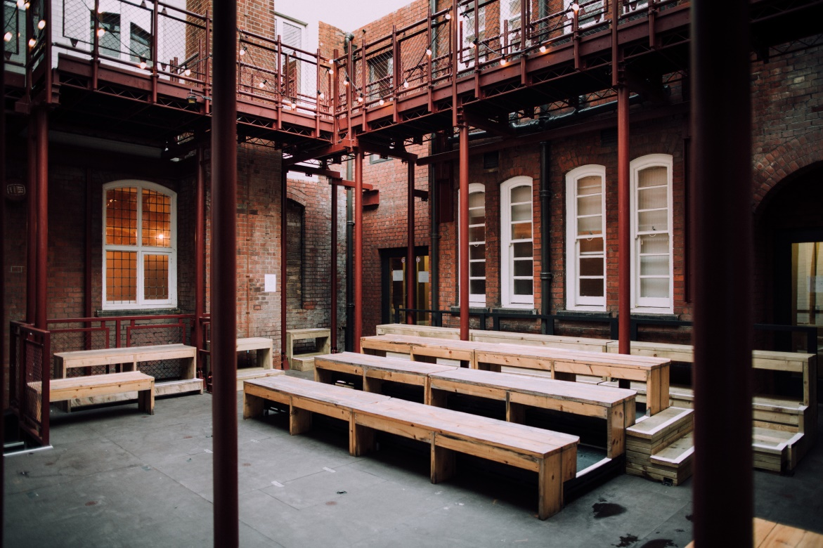
If you want to go upstairs for a show, a class or to explore, you can use the stairs or the lift. The lift can be reached by going down the halls off the foyer. This is the lift.
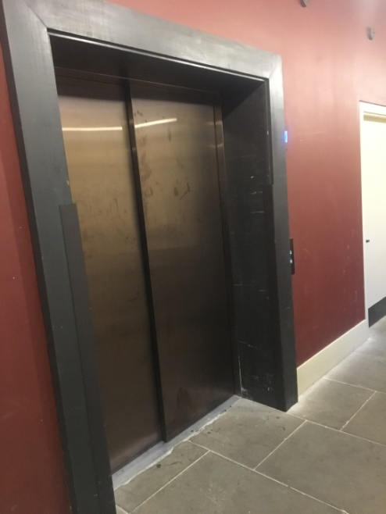
If you need a break from whatever you’re doing or from the building, you can go to the chill out space. The chill out space is on the first floor. It is quiet in the chill out space. You can turn the lights up or down. There are pillows, mats and blankets so you can lie down if you want.
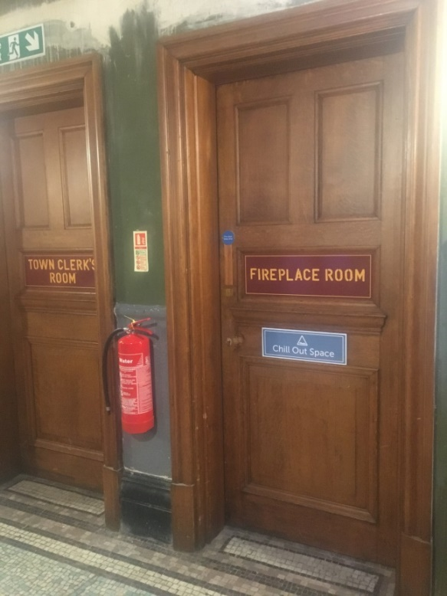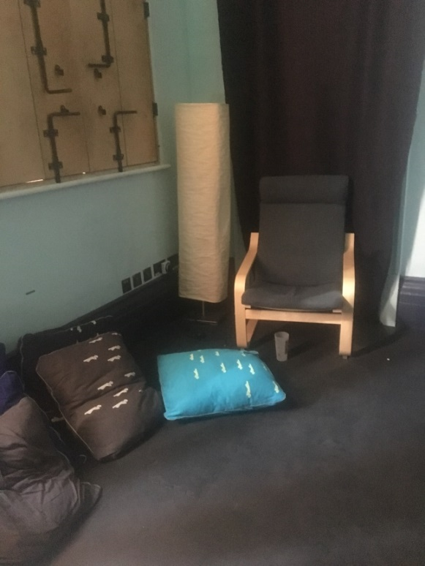
There are many different toilets in the building. Most of them are located near the courtyard.
On the ground floor there are men’s, women’s and gender neutral accessible toilets on either side of the foyer. This is the men’s toilets on the ground floor.
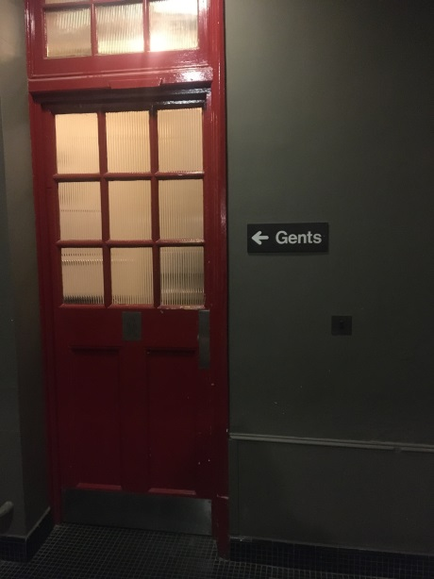
This is the women’s toilets on the ground floor.
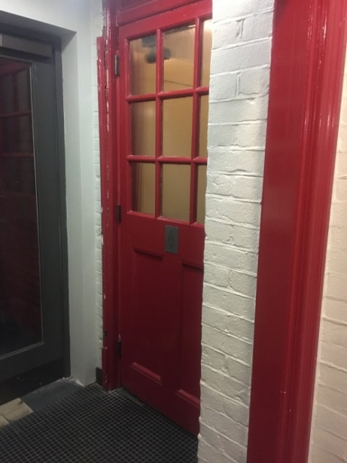

This is the accessible toilet by the women’s toilets on the ground floor
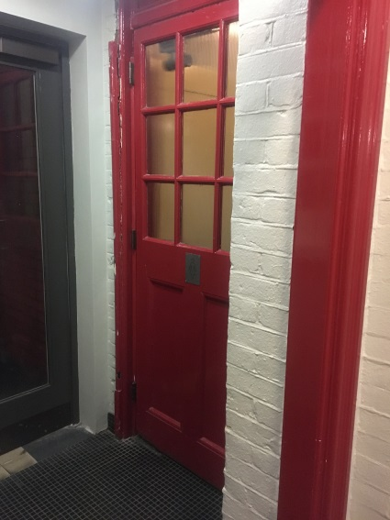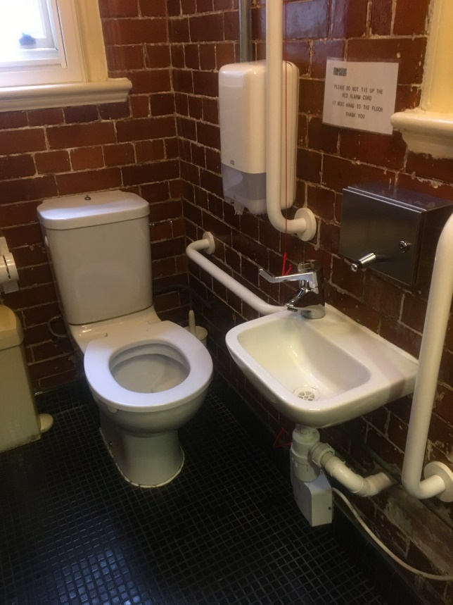

This is the accessible toilet near the men’s toilet on the ground floor
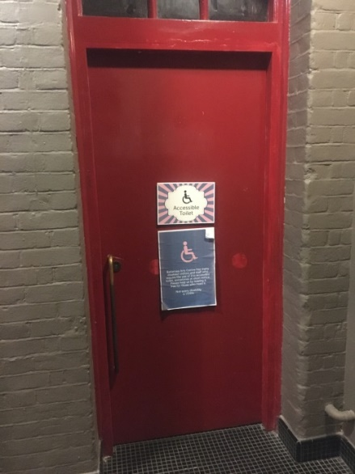
On the first floor there is a single stall accessible toilet, a women’s toilet and a gender neutral toilet.
This is the single stall accessible toilet.
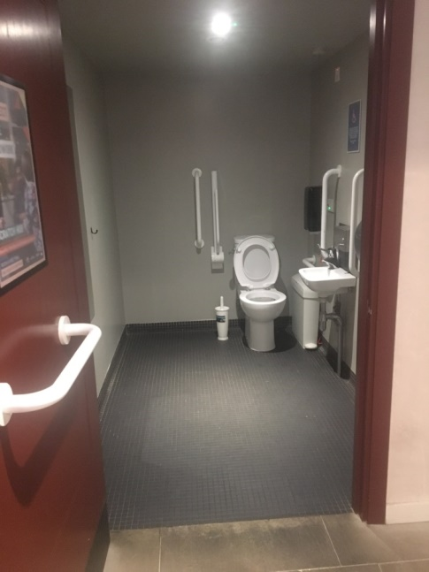
These are the women’s toilets on the second floor.
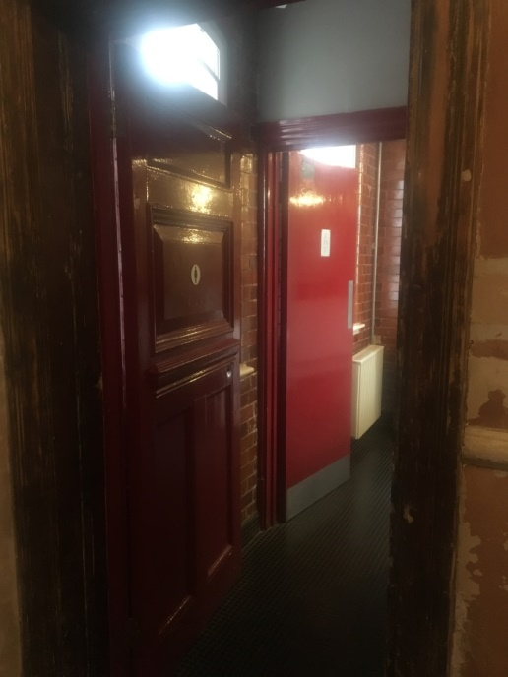
These are the men’s toilets on the second floor
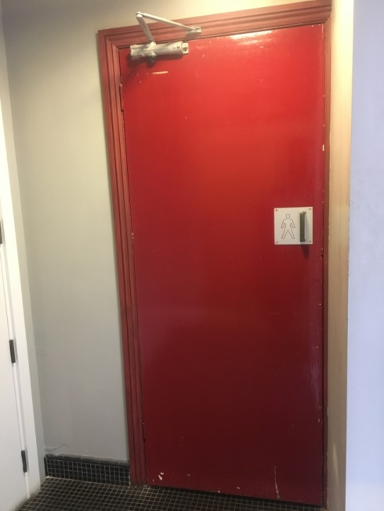

This is the gender neutral toilet. It is located down the hallway with hands coming out of the wall.
